**The Intro to Java Script:**The computer is a dumb Machin which runs on the instruction we give it .  
In other words computer follows step by step instructions given to it.  
In technical terms computer runes on the Algorithm we program it for..  
  
ok what was that Algorithm follows ..?

To keep it simple Algorithms are step by step process of solving a problem   
Example: Preparing tea step1: step2: ….so on..  
  
Now JS runes / follows ECMAScript it is a standard that all JS developers agreed to follow to avoid conflicts.  
JS is liberal language which is not strictly binded

We use JS to provide functional interface to ServerSide code  
  
JS can be implemented in 3 ways internal, Inline(limited), External  
  
  
  
  
Now coding area

:The code for implementing Inline JS:

<!DOCTYPE html>

<html>

<body>

<h2>My First JavaScript</h2>

<button type="button"

onclick="document.getElementById('demo').innerHTML = Date()">

Click me to display Date and Time.</button>

<p id="demo"></p>

</body>

</html>

Programe for inline Js to get the date

The output of the same::  
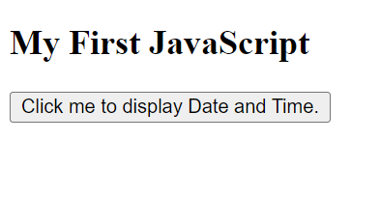 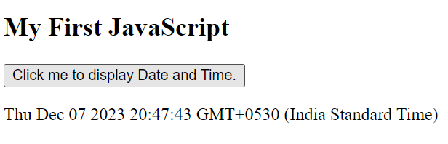

Ii

Variables:  
  
Variables are like containers where u can store string, number, array, object, …  
JS is a dynamically typed language as u can change the variable types on runtime

Var a=33  
var a=”niki”  
Console.log(a)

Rules:  
Letters, digits, signes, underscrolles can be used must begin with a,$, _ ,-   
  
Number not allowed. 🡪 var 2=10 no  
  
Cannot use reserved words 🡪 var var =2/ var let =7  
niki, Niki are different variabules  
  
Differences between var, let and const.  
Var 🡪 Global scope no block scope Pre Es6  
Now what is Block Scope 🡪 may be with in a function or something like this

Var a=23

//Block below is Block

{

Var a=2

}

Now Console.log(a) 🡪 2  
as var is global effects all over  
--------------------------------------------  
Now same with Let  
let a=23

//Block below is Block

{

let a=2

}  
  
console.log(a) 🡪 23 why with in block(andar ki bath andar) and this looks for any globally available thing yes it is 23

---------------------------------------

Const a =3

Const 🡪 Block Scope, cannot change once declared special case for Array and Objects, not allowed reassigning and redeclaration .  
  
Let 🡪Block Scope, u cannot redeclare with in global or block Scope, reassigning allowed

|  |  |  |  |  |  |
| --- | --- | --- | --- | --- | --- |
|  | Redeclare | Reassign | Hoisted | Binds this | Scope |
| var | No | Yes | Yes | Yes | Yes |
| let | Yes | No | Yes | No | No |
| const | Yes | No | No | No | No |

|  |  |
| --- | --- |
| Redeclaring | Reassigning |
| Let x=10  Let x =20 // not allowed | let x = 10;  console.log(x); // Output: 10  // Reassigning the value of x  x = 20;  console.log(x); // Output: 20 |

Java is a static type language where u need to declare the variable and it’s type before u use it.